The system will be reading data from the accelerometer which will be use as an tilt sensor to know whenever the balance is positioned horizontally or not. If the system detects that the balance is not perfectly horizontal it will fix it using the movement mechanism and provide the user with the measure of the force components that were require to reposition the balance horizontally.

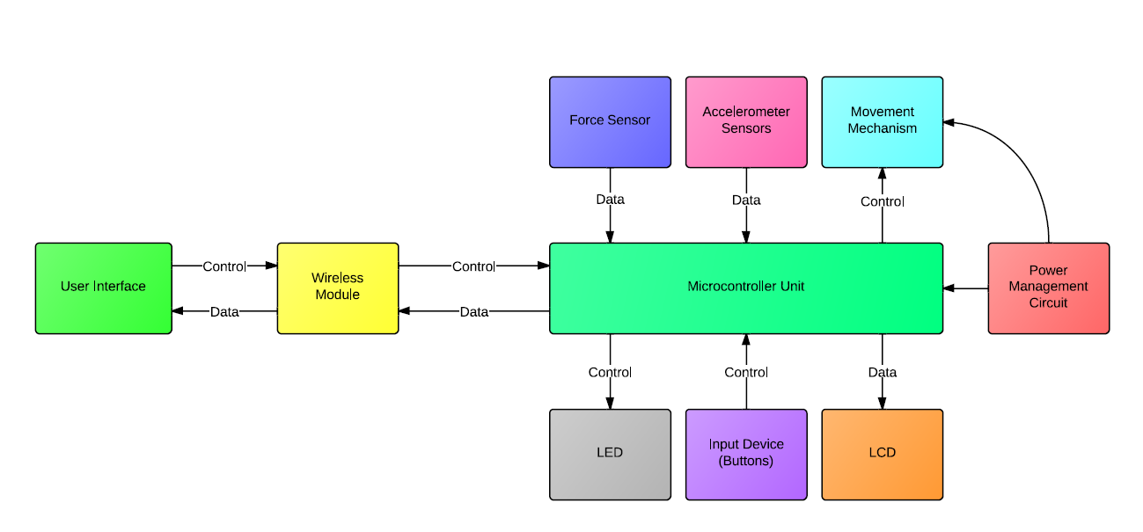

Components:

1. Microcontroller - The microcontroller will be use to process data, control the mechanics and manage the communication with the wireless module.
2. Force Sensor - The force sensors will be use to measure the forces been applied to the object on the experiment by the wind.

1. Accelerometer - The accelerometer will be use to keep track of the position in which the balance is through the experiment.
2. Wireless Module - The wireless module will be use to send data to a remote user interface for data logging purposes.
3. LCD - The LCD will be use to display data and user feedback.
4. LED - The LEDs will be use to display system status.
5. Buttons - The buttons will be use for user input.
6. Computer Interface - A computer interface will be provide to visualize data collected via wireless module.
7. Power Management Circuit - The power management circuit will be use to provide the necessary power to every component on the system.
8. Movement Mechanism - The movement mechanism will be use to control the balance position.

Software functions:

1. Develop an function that track balance position.
2. Develop an function that track force sensor data.
3. Develop an function that store sensors data.
4. Develop an function that control movement mechanism based on force sensor data and balance position.
5. Develop functions to calculate aerodynamic parameters based on logged data.
6. Develop functions for communication protocols.
7. Develop functions to communicate with user interface.
8. Develop functions for LCD UI.
9. Develop functions for system control.
10. Develop user interface.